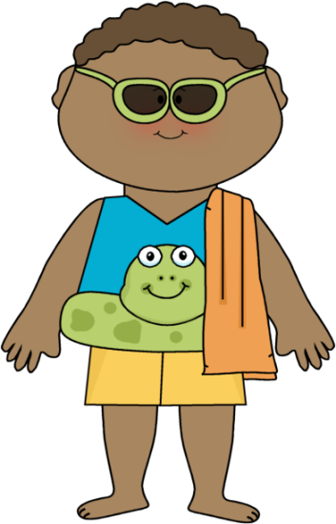 **Kindergarten Connection** 

**May 2025**

**Language Arts Skills:**

|  |  |  |  |
| --- | --- | --- | --- |
| **Letter Sounds:**  **U.F.L.I Lessons**  **-es, -ed, ing, u_e, VCEe review** | **High Frequency Words:**  Two, does, many, any, been, into, friend, one, once | **Comprehension Strategies/Skills:**  Visualize, Ask & Answer Questions, Create New Understanding,  Compare Texts  **Savvas Themes:**  Best weather,  Ocean | **Literacy Skills:**    Closed and open syllables  Compound words |

**Math:**

Chapter 19: Measurement

Chapter 20: Data

Getting Ready For First Grade

**Science:**

Unit 2: Butterfly Life Cycles, Animals and End of Year Ocean Unit

**Social Studies:**

Maps, Globes & Landforms/ US Symbols/Summer/Water Safety

**Important Dates:**

5/2 First Friday – Wear Nest Shirts

5/2 Killearn Lakes Taekwondo (on campus visit)

5/15 P.T.O. @ 7

5/16 Patriotic Parent Picnic, 10:30-11:30 *Wear Patriotic Attire*

5/21-5/23 Early Release @ 12:20

5/23 Last Day of School

|  |  |  |
| --- | --- | --- |
| **Wednesday, May 21st**  **K Craft Day**  *Early Release Day (12:20)* | **Thursday, May 22nd**  **Free Choice Frenzy**  *Early Release Day (12:20)* | **Friday, May 23rd**  Movie and Popcorn Day  *Early Release Day (12:20)*  **Last Day of Kindergarten!** |

**Thank you for your ongoing support!**

**The Kindergarten Teachers,**

**Mrs. Campbell, Mrs. Deason, Ms. Hammond, Mrs. Lindsey,**

**Mrs. Ramos, Ms. Randall, Mrs. Rockwood**